Chapter 3, Solution 88

Determine the gain v_{o}/v_{s} of the transistor amplifier circuit in Fig. 3.124.

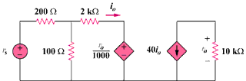

Figure 3.124
For Prob. 3.88.

Solution

Let v₁ be the potential at the top end of the 100-ohm resistor.

(v_{s} – v₁)/200 = v₁/100 + (v₁ – 10⁻³v₀)/2000 (1)

For the right loop, v₀ = -40i₀(10,000) = -40(v₁ – 10⁻³)10,000/2000,

or, v₀ = -200v₁ + 0.2v₀ = -4x10⁻³v₀ (2)

Substituting (2) into (1) gives, (v_{s} + 0.004v₁)/2 = -0.004v₀ + (-0.004v₁ – 0.001v₀)/20

This leads to 0.125v₀ = 10v_{s} or (v₀/v_{s}) = 10/0.125 = –80

